Course Project
DeVry University
College of Engineering and Information Sciences

Screenshot of program running:
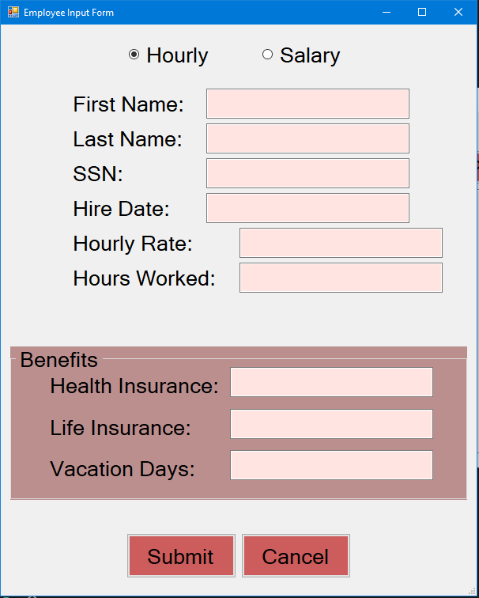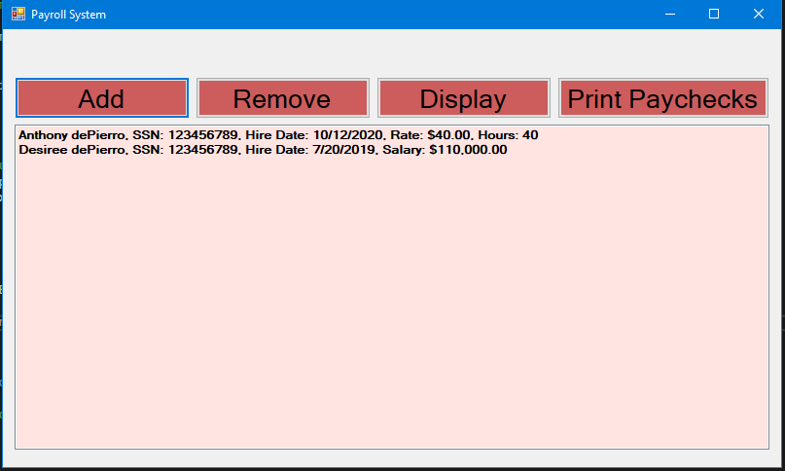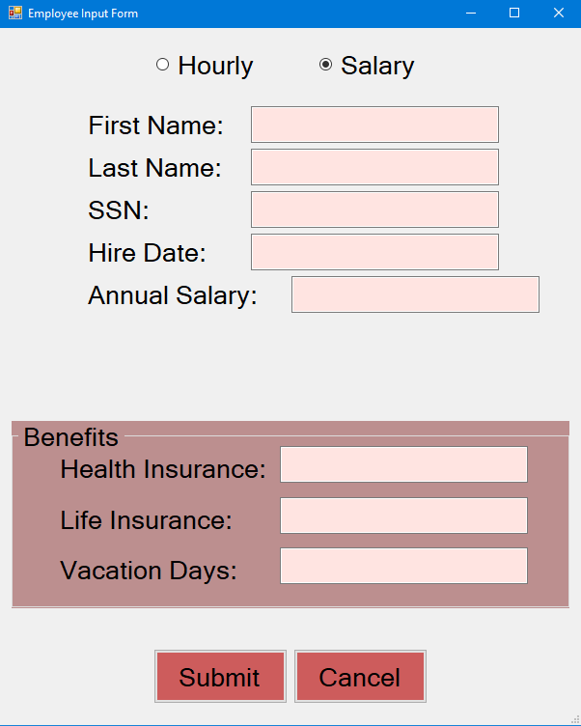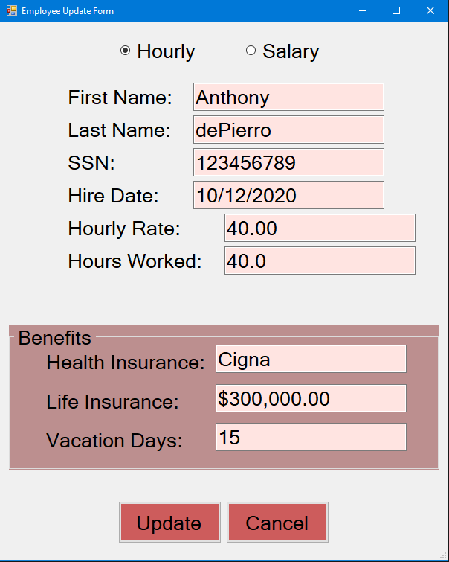

Form code (only the code for the form, not program.cs):

amespace dePierro_CourseProject_part2
{
public partial class MainForm : Form
{

// form level references
const string FILENAME = "Employees.dat";

public MainForm()
{
InitializeComponent();
}

private void AddButton_Click(object sender, EventArgs e)
{

//Add item to the employee list box
InputForm frmInput = new InputForm();
DialogResult result = frmInput.ShowDialog();

//see if input form was cancelled
if (result == DialogResult.Cancel)
return; //end the method since user canceled

//get users input and create an employee object
string fName = frmInput.FirstNameTextBox.Text;
string lName = frmInput.LastNameTextBox.Text;
string ssn = frmInput.SSNTextBox.Text;
string date = frmInput.HireDateTextBox.Text;
DateTime hireDate = DateTime.Parse(date);
string healthIns = frmInput.HealthInsTextbox.Text;
double lifeIns = Double.Parse(frmInput.LifeInsTextBox.Text);
int vacation = int.Parse(frmInput.VacationTextBox.Text);

//dispose of the imput form and clean the RAM
//frmInput.Dispose();

Benefits benefits = new Benefits(healthIns, lifeIns, vacation);
Employee emp;

if (frmInput.HourlyRadioButton.Checked)
{
float hourlyRate = float.Parse(frmInput.Pay1TextBox.Text);
float hoursWorked = float.Parse(frmInput.Pay2TextBox.Text);

emp = new Hourly(fName, lName, ssn, hireDate, benefits, hourlyRate, hoursWorked);
}
else if (frmInput.SalaryRadioButton.Checked)
{
double salary = Double.Parse(frmInput.Pay1TextBox.Text);

emp = new Salary(fName, lName, ssn, hireDate, benefits, salary);
}
else
{
MessageBox.Show("Error. Invalid Employee type");
return;
}

//add employee object to the list
EmployeesListBox.Items.Add(emp);

//write all employee objects to the file
WriteEmpsToFile();
}

private void WriteEmpsToFile()
{

// convert the list box items to a generic list
List<Employee> empList = new List<Employee>();

foreach (Employee emp in EmployeesListBox.Items)
{
empList.Add(emp);
}

// open a pipe to the file and create a translator
FileStream fs = new FileStream(FILENAME, FileMode.Create);
BinaryFormatter formatter = new BinaryFormatter();

//write the generic list to the file
formatter.Serialize(fs, empList);

// close the pipe
fs.Close();

//tell user that the records were written
MessageBox.Show("Employees were written to the file");
}

private void RemoveButton_Click(object sender, EventArgs e)
{
//Remove Items from Employee list box
int itemNumber = EmployeesListBox.SelectedIndex;

if (itemNumber > -1)
{
EmployeesListBox.Items.RemoveAt(itemNumber);
MessageBox.Show("Employee removed!");
//write all employee objects to the file
WriteEmpsToFile();
}
else
{
MessageBox.Show("Please select the Employee you would like to remove");
}
}

private void DisplayButton_Click(object sender, EventArgs e)
{
//clear the list bpx
EmployeesListBox.Items.Clear();

//read all employee objects from the file
ReadEmpsFromFile();
}

private void ReadEmpsFromFile()
{
// check to see if the file exists
if(File.Exists(FILENAME) && new FileInfo(FILENAME).Length > 0)
{
// create a pip from the file and create the translator
FileStream fs = new FileStream(FILENAME, FileMode.Open);
BinaryFormatter formatter = new BinaryFormatter();

//read all emlpoyee objects from the file
List<Employee> empList = (List<Employee>)formatter.Deserialize(fs);

//close the pipe
fs.Close();

// copy the employee objects into listbox
foreach(Employee emp in empList)
EmployeesListBox.Items.Add(emp);

}
}

private void PrintPaychecksButton_Click(object sender, EventArgs e)
{
MessageBox.Show("Printing employee paychecks");
}

private void MainForm_Load(object sender, EventArgs e)
{
//load the employees from the file
ReadEmpsFromFile();
}

private void EmployeesListBox_SelectedIndexChanged(object sender, EventArgs e)
{

}

private void EmployeesListBox_DoubleClick(object sender, EventArgs e)
{
//edit selected employee in list box
InputForm frmUpdate = new InputForm();

using(frmUpdate)
{
frmUpdate.Text = "Employee Update Form";
frmUpdate.SubmitButton.Text = "Update";

int itemNumber = EmployeesListBox.SelectedIndex;

if(itemNumber < 0)
{
MessageBox.Show("Error. Invalid Employee");
return;
}

Employee emp = (Employee)EmployeesListBox.Items[itemNumber];

frmUpdate.FirstNameTextBox.Text = emp.FirstName;
frmUpdate.LastNameTextBox.Text = emp.LastName;
frmUpdate.SSNTextBox.Text = emp.SSN;
frmUpdate.HireDateTextBox.Text = emp.HireDate.ToShortDateString();
frmUpdate.HealthInsTextbox.Text = emp.BenefitsPackage.HealthInsurance;
frmUpdate.LifeInsTextBox.Text = emp.BenefitsPackage.LifeInsurance.ToString("C2");
frmUpdate.VacationTextBox.Text = emp.BenefitsPackage.Vacation.ToString();

if(emp is Hourly )
{
Hourly hrly = (Hourly)emp;
frmUpdate.HourlyRadioButton.Checked = true;
frmUpdate.Pay1TextBox.Text = hrly.HourlyRate.ToString("N2");
frmUpdate.Pay2TextBox.Text = hrly.HoursWorked.ToString("N1");
}
else if(emp is Salary)
{
Salary sal = (Salary)emp;
frmUpdate.SalaryRadioButton.Checked = true;
frmUpdate.Pay1TextBox.Text = sal.AnnualSalary.ToString("N2");
}

DialogResult result = frmUpdate.ShowDialog();

if (result == DialogResult.Cancel)
return; //end of the method since user canceled the update

EmployeesListBox.Items.RemoveAt(itemNumber);

// get users updated input and create emp object
string fName = frmUpdate.FirstNameTextBox.Text;
string lName = frmUpdate.LastNameTextBox.Text;
string ssn = frmUpdate.SSNTextBox.Text;
string date = frmUpdate.HireDateTextBox.Text;
DateTime hireDate = DateTime.Parse(date);
string healthIns = frmUpdate.HealthInsTextbox.Text;

// pull a substring that does not contain the initial dollar sign
string lifeInsString = frmUpdate.LifeInsTextBox.Text;
lifeInsString = lifeInsString.Substring(1);
double lifeIns = Double.Parse(lifeInsString);
int vacationDays = Int32.Parse(frmUpdate.VacationTextBox.Text);

Benefits benefits = new Benefits(healthIns, lifeIns, vacationDays);

if(frmUpdate.HourlyRadioButton.Checked)
{
float rate = float.Parse(frmUpdate.Pay1TextBox.Text);
float hours = float.Parse(frmUpdate.Pay2TextBox.Text);
emp = new Hourly(fName, lName, ssn, hireDate, benefits, rate, hours);
}
else if(frmUpdate.HourlyRadioButton.Checked)
{
double salary = double.Parse(frmUpdate.Pay1TextBox.Text);
emp = new Salary(fName, lName, ssn, hireDate, benefits, salary);
}

//add the updated employee object to the employee list box
EmployeesListBox.Items.Add(emp);

//write all of the updated employee objects to the file
WriteEmpsToFile();
}
}
}
}

namespace dePierro_CourseProject_part2
{
public partial class InputForm : Form
{
public InputForm()
{
InitializeComponent();
}

private void SubmitButton_Click(object sender, EventArgs e)
{
this.DialogResult = DialogResult.OK;
this.Hide();
}

private void ExitButton_Click(object sender, EventArgs e)
{
this.DialogResult= DialogResult.Cancel;
}

private void HourlyRadioButton_CheckedChanged(object sender, EventArgs e)
{
ShowControls();
}

private void SalaryRadioButton_CheckedChanged(object sender, EventArgs e)
{
ShowControls();
}
private void ShowControls()
{
if(HourlyRadioButton.Checked)
{
Pay1Label.Text = "Hourly Rate: ";
Pay2Label.Text = "Hours Worked: ";
Pay2Label.Visible = true;
Pay2TextBox.Visible = true;
}
else if(SalaryRadioButton.Checked)
{
Pay1Label.Text = "Annual Salary: ";
Pay2Label.Visible= false;
Pay2TextBox.Visible = false;
}
}

}
}

namespace dePierro_CourseProject_part2
{
[Serializable]

internal class Employee
{
// Attributes
protected string firstName;
protected string lastName;
protected string ssn;
protected DateTime hireDate;
protected Benefits benefits;

// Constructors
public Employee()
{
firstName = "unknown";
lastName = "unknown";
ssn = "unknown";
hireDate = DateTime.MinValue;
}

public Employee( String firstName, string lastName, string ssn, DateTime hireDate, Benefits benefits )
{
this.FirstName = firstName;
this.LastName = lastName;
this.ssn = ssn;
this.hireDate = hireDate;
BenefitsPackage = benefits;
}

// Behaviors
public override string ToString()
{
// Anthony dePierro, SSN: 555-55-5555, hire date: XX/XX/XXXX
return firstName + " " + lastName + ", SSN: " + ssn + ", Hire Date: " + hireDate.ToShortDateString();
}

public virtual double CalculatePay()
{
return 0.0;
}

// Properties
public string FirstName
{
get
{
return firstName;
}
set
{
if (value.Length > 0)
firstName = value;
else
firstName = "unknown";
}
}
public string LastName
{
get
{
return lastName;
}
set
{
if (value.Length > 0)
lastName = value;
else
lastName = "unknown";
}
}
public string SSN
{
get
{
return ssn;
}
set
{
if (value.Length == 9 || value.Length == 11)
ssn = value;
else
ssn = "unknown";
}
}

public DateTime HireDate
{
get
{
return hireDate;
}
set
{
if (value.Year > 1950 && value.Year <= DateTime.Now.Year + 1)
hireDate = value;
else
hireDate = DateTime.MinValue; // 01/01/0001
}
}

public Benefits BenefitsPackage
{
get
{
return benefits;
}
set
{
this.benefits = value;
}
}

}
}

namespace dePierro_CourseProject_part2
{
[Serializable]
internal class Salary : Employee
{
// attributes
private double annualSalary;

// constructors
public Salary() : base()
{
annualSalary = 0.0;
}

public Salary(string firstName, string lastName, string ssn,
DateTime hireDate, Benefits benefits, double annualSalary) :
base(firstName, lastName, ssn, hireDate, benefits)
{
AnnualSalary = annualSalary;
}

// behaviors
public override string ToString()
{
return base.ToString() + ", Salary: " + annualSalary.ToString("C");
}

public override double CalculatePay()
{
return annualSalary / 26.0;
}

// properties
public double AnnualSalary
{
get
{
return annualSalary;
}
set
{
if (value > 0.0 && value < 1000000.0)
annualSalary = value;
else
annualSalary = 0.0;
}
}
}
}

namespace dePierro_CourseProject_part2
{
[Serializable]
internal class Hourly : Employee
{
//attributes
private float hourlyRate;
private float hoursWorked;

//constructors
public Hourly() : base()
{
hourlyRate = 0.0f;
hoursWorked = 0.0f;
}

public Hourly (String firstName, string lastName, string ssn, DateTime hireDate,
Benefits benefits, float hourlyRate, float hoursWorked) : base(firstName, lastName, ssn, hireDate, benefits)
{
HourlyRate = hourlyRate;
HoursWorked = hoursWorked;
}

//behaviors
public override string ToString()
{
return base.ToString() + ", Rate: " + hourlyRate.ToString("C") +
", Hours: " + hoursWorked.ToString();
}

public override double CalculatePay()
{
double pay = 0.0;

if(HoursWorked > 40.0f)
{
double basePay = hourlyRate * 40.0f;
double overtime = (hoursWorked - 40.0f) * hourlyRate * 1.5f;
pay = basePay + overtime;
}
else
{
pay = hoursWorked * hourlyRate;
}
return pay;
}

//properties
public float HourlyRate
{
get
{
return hourlyRate;
}
set
{
if (value > 0.0f && value <= 1000.0f)
hourlyRate = value;
else
hourlyRate = 0.0f;
}
}
public float HoursWorked
{
get
{
return hoursWorked;
}
set
{
if (value > 0.0f && value <= 160.0f)
hoursWorked = value;
else
hoursWorked = 0.0f;
}
}
}
}

namespace dePierro_CourseProject_part2
{
[Serializable]
internal class Benefits
{
// attributes
private string healthInsurance;
private double lifeInsurance;
private int vacation;

// constructors
public Benefits()
{
healthInsurance = "unknown";
lifeInsurance = 0.0;
vacation = 0;

}

public Benefits (string healthInsurance, double lifeInsurance, int vacation)
{
this.HealthInsurance = healthInsurance;
this.LifeInsurance = lifeInsurance;
Vacation = vacation;
}

// behaviors
public override string ToString()
{
return "HealthInsurance: " + healthInsurance + ", LifeInsurance: " + lifeInsurance +
", VacationDays: " + vacation;
}

// properties (get/set methods)
public string HealthInsurance
{
get
{
return healthInsurance;
}
set
{
if (value.Length > 0)
healthInsurance = value;
else
healthInsurance = "unknown";
}
}

public double LifeInsurance
{
get
{
return lifeInsurance;
}
set
{
if (value > 0.0 && value <= 10000000.0)
lifeInsurance = value;
else
lifeInsurance = 0.0;
}
}
public int Vacation
{
get
{
return vacation;
}
set
{
if (value > 0 && value <= 40)
vacation = value;
else
vacation = 0;
}
}

}
}

